start(□)+(send+wait+show)*□+stop - регулярное выражение

задание 4:

|  |  |  |  |  |  |  |  |
| --- | --- | --- | --- | --- | --- | --- | --- |
|  | start | □ | λ | send | show | wait | stop |
| S1 | S2 |  |  |  |  |  |  |
| S2 |  | S2, S3 |  |  |  |  |  |
| S3 |  |  | S4 | S3, S4 | S3, S4 | S3, S4 |  |
| S4 |  | S4, S5 |  |  |  |  |  |
| S5 |  |  |  |  |  |  |  |

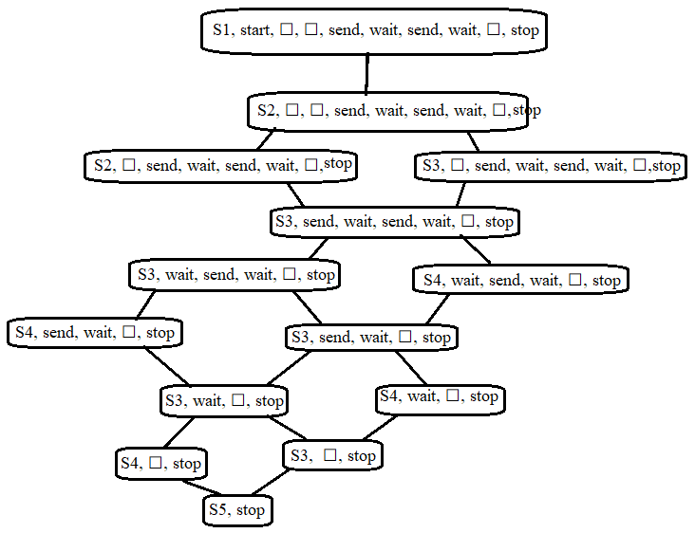

Задание 5:

